CHAPTER 2 ARRAYS

2.1 Abstraction Data Types and the C++ Class

중요 공부 내용

ADT 정의할 수 있는 능력

Representation

Efficiency를 위한 데이터 구조 표현

알고리즘

성능 분석

* 학습 목표(source code로 학습)

- polynomial class를 정의

1) static 사용하지 않는 경우

2) static 사용하는 경우

- matrix class를 정의

1) matrix의 transpose, multifly

2) sparse matrix를 표현

2.1.1 An Introduction to the C++ Class

the class

support the distinction between specification and implementation

hide the implementation of an ADT from its users

Definitions of the C++ class: program 2.1

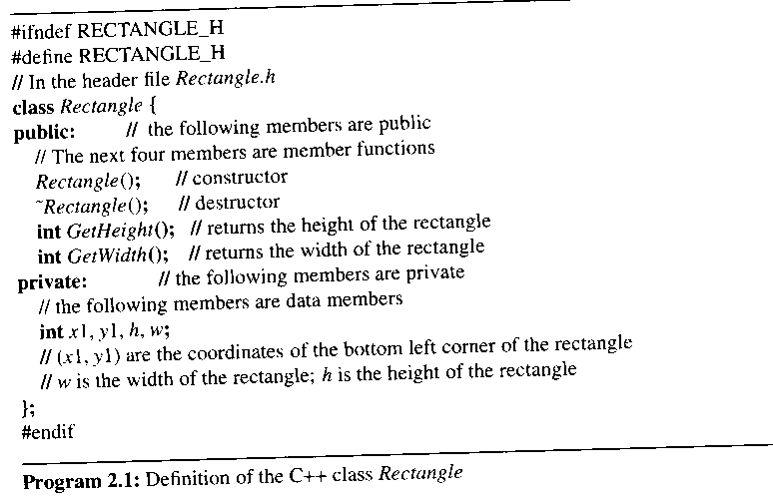

2.1.2 Data Abstraction and Encapsulation in C++

separate the specification of the operations of a class from their implementation

the specification -> program 2.1(Not yet ADT)

must be contained inside the public portion of the class definition

consists of the names of every public member function, the type of its arguments, and the type of its result

function prototype

should be a description of what the function does

achieved in C++ by using comments

place the specification of an operation in a named header file

program 2.1 (placed in Rectangle.h)

place the implementations of the functions in a source file of the same name
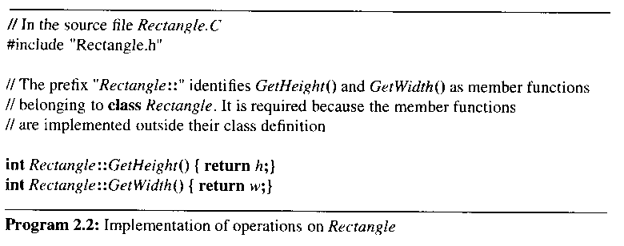

2.1.3 Declaring Class Objects and Invoking Member Functions

declare class objects(instance objects) as variables

invoke members of an object by using the component selection operators, a dot(.) and an arrow(->)
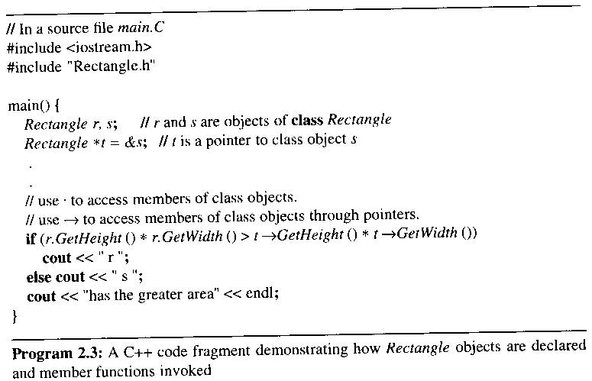

2.1.5 Miscellaneous Topics

union

no way to know what the data type is until runtime

reserve storage for the largest of its data members

static class data member

a global variable for its class

only one copy of a static data member and all instance objects must share it

class Polynomial {

private:

static term termArray[MaxTerms];

static int free;

int Start, Finish;

};

main(){

term Polynomial::termArray[MaxTerms];

//definition of the static data member

int Polynomial::free = 0;

}

2.1.6 ADTs and C++ classes

use the C++ class to define an ADT instead of the notation of ADT 1.1

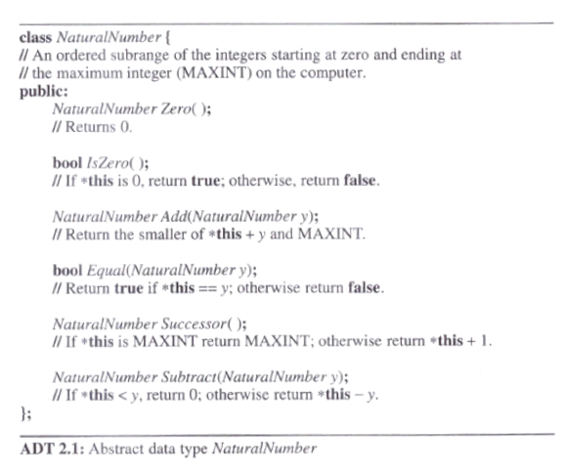

2.2 The Array as an Abstract Data Type

an array is a set of pairs, <index, value>, no two pairs in this set have the same index

we call the index a correspondence or a mapping

concerned with the operations that can be performed on an array

retrieve a value

store a value
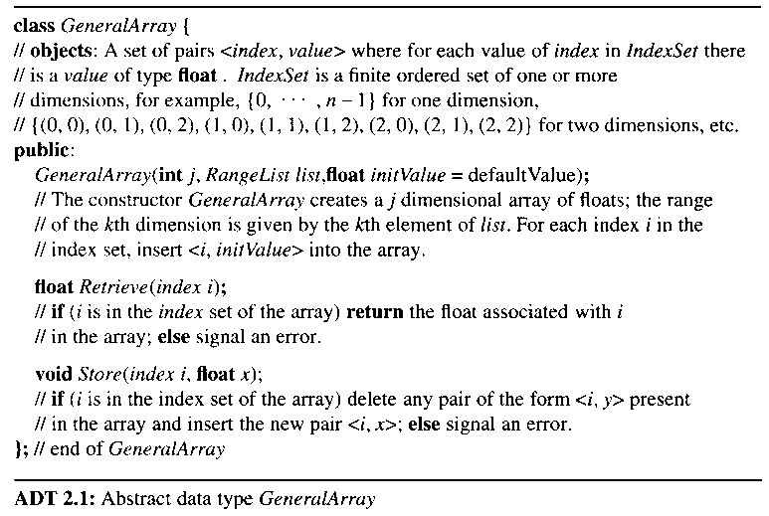

the advantage of ADT definition

the array is a more general structure than "a consecutive set of memory locations"

more general than the C++ array

more flexible about the composition of the index set

Retrieve (index i) //i is in the index set of the array

the C++ array

require the index set to be a set of consecutive integers starting at 0

do not check an array index

a C++ array example of floats

float exampIe[n];

accessed in two ways: example[i], or *(example+i)

2.3 The Polynomial Abstraction Data Type

ordered, or linear list

one of the simplest and most common data structures

list: (a₀, a₁, …, a_{n-1})

many operations on lists

find the length, n, of the list

read the list from left to right

retrieve the i_{th} element

store a new value into the i_{th} position

insert a new element at the position i

delete the element at position i

a problem requiring ordered lists: the representation and manipulation of symbolic polynomials

A(x) = 3x2 + 2x + 4

B(x) = x4 + 10x3 + 3x2 + 1

degree : the largest exponent of a polynomial

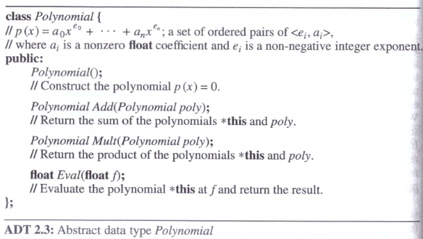
A(x) + B(x), A(x) * B(x)

2.3.1 Polynomial Representation
* to arrange unique exponents in decreasing order

Representation 1: to define the private data members of Polynomial

private:

int degree;

float coef[MaxDegree + 1];

represent the polynomial A(x) as:

a.degree = n

a.coef[i] = a_{n-i}, 0 <= i <= n

a.coef[i] = the coefficient of xn-i

store the coefficients in order of decreasing exponents

Representation 2:

if a.degree « MaxDegree, then a.coef[0], ..., a.coef[N] are unused

define coef[degree+1] so that its size is a.degree + 1

private:

int degree;

float *coef;

adding the following constructor to Polynomial:

Polynomial::Polynomial(int d)

{

degree = d;

coef = new float [degree + 1];

}

Representation 3:

consider polynomials that have many zero terms, called sparse polynomials

x1000 + 1

b_{m}x^{em} + b_{m-1}x^{em-1} + . . . b₀x^{e0}

b₀ = a nonzero coefficient of A

ei decreasing e_{m} > e_{m-1}> ... > e₀ ≥ 0

represent polynomials in a single array called termArray

the singe array termArray is to be shared by all polynomials: a static class data member of Polynomial

class Polynomial; // forward declaration

class term {

friend Polynomial;

private:

float coef;

int exp;

}

define the private data members of polynomial as follows:

private:

//A, B에 의해 공유됨, page 94

static term termArray[MaxTerms];

static int free;

int Start, Finish

the required definitions of the static class members outside the class definition: page 94

term Polynomial::termArray[MaxTerms];

int Polynomial::free = 0;

A(x) = 2x1000 + 1

B(x) = x4 + 10x3 + 3x2 +1
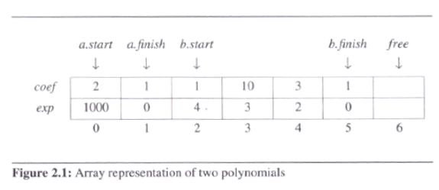

2.3.2 Polynomial Addition
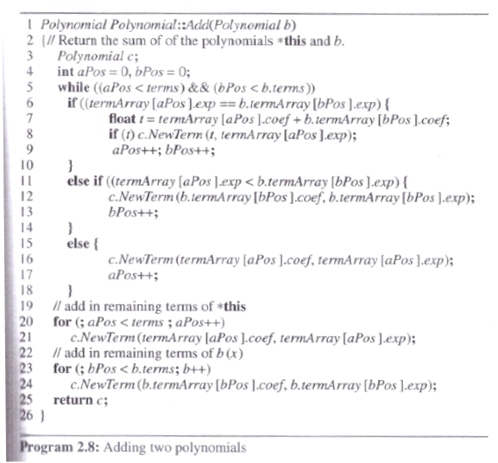

C = A + B

merging the terms of the two polynomials
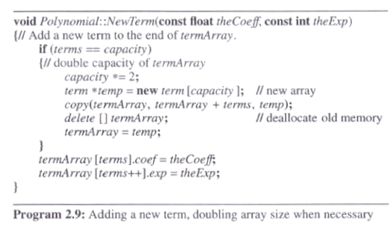

Analysis of Add:

let m and n be # of nonzero terms in A and B

# of iterations the while loop: m + n + 1

O(n + m) since non of the exponents are the same in A and B

2.4 SPARSE MATRICES

2.4.0 The class Matrix

Template<class T>

class Matrix {

public:

Matrix(int r=0, int c=0);

Matrix(const matrix<T>& m);

~Matrix() {delete [] element;}

Int Rows() const {return rows;}

Int Columns() const {return cols;}

T& operator() (int i, int j) const;

. . .

private:

int rows, cols;

T *element;

};

2.4.1 Introduction

sparse matrices

have many zero entries

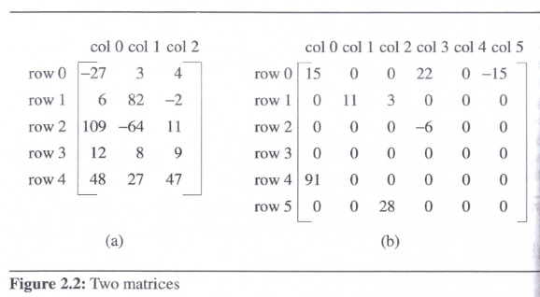

consider an alternate form of representation

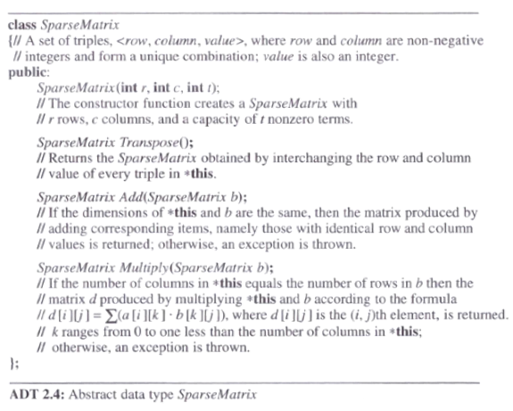
should explicitly store only the nonzero elements

2.4.2 Sparse Matrix Representation

a set of triples 표현

represent a matrix by using the triple <row, col, value>

use an array of triples to represent a sparse matrix

row-major ordering

the column indices are in ascending order

class SparseMatrix;

//triples <row, column, value> 표현

class MatrixTerm {

friend class SparseMatrix

private:

int row, col, value;

};

class SparseMatrix {

private:

int rows, cols, terms, capacity;

// set 표현

MatrixTerm *smArray;

};

// Rows: # of rows, Cols : # of columns, Terms : # of nonzero terms

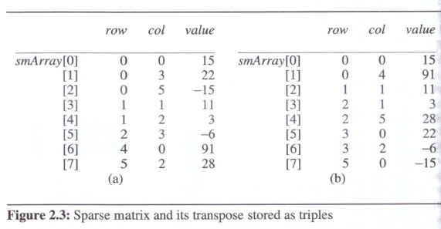

2.4.3 Transposing a Matrix

transpose a matrix

must interchange the rows and columns

for (each row i)

take element (i, j, value) and

store it in (j, i, value) of the transpose

the difficulty of transposing a matrix

not know where to put the element (j, i, value) until all other elements that precede it have been processed

(0, 0, 15) becomes (0, 0, 15) // no problem

(0, 3, 22) becomes (3, 0, 22) // where to put ??

for (all elements in column j)

place element (i, j, value) in position (j, i, value)

"find all elements in column 0 and store them in row 0"
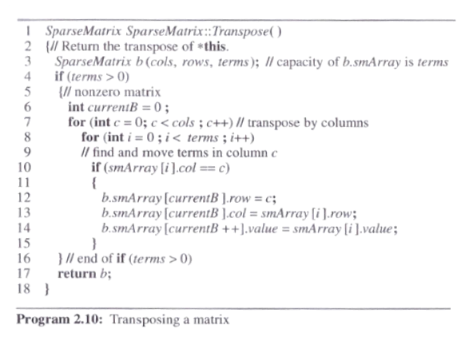

the variable CurrentB : the position in b where the next term in the transpose is to be inserted

Analysis of Transpose

O(terms * columns) // terms = rows * columns

becomes O(rows * columns2) where terms = columns * rows

the computing time of the transpose of a rows x columns matrix in time Ο(rows * columns)

for (int j = 0; j < cols, …)

for (int i = 0; I < rows, …)

B[j][I] = A[I][j]

transpose a matrix represented as a sequence of triples in time Ο(terms + columns)

called FastTranspose

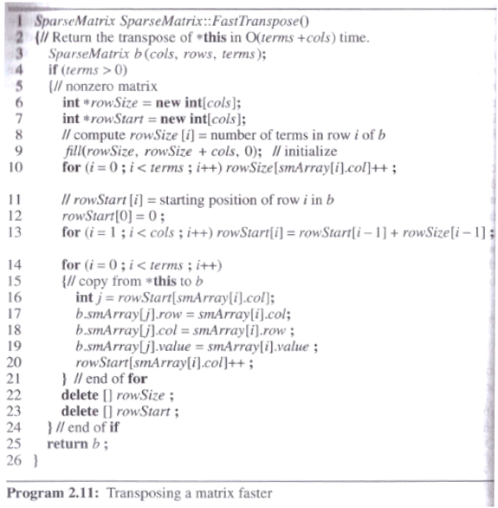

proceeds by first determining the number of elements in each column of A

obtain easily the starting point in b of each of its rows

the starting point, RowStart[i] of row i, of B

= RowStart[i-1] + RowSize[i-1]

// RowSize[i-1] = # of elements in row i-1 of B

after execution of the third for loop(line 13), the values of RowSize and RowStart:

[0] [1] [2] [3] [4] [5]

RowSize = 3 2 1 0 1 1

RowStart= 0 3 5 6 6 7

the computing time of FastTranspose

O(columns + terms)

four loops in fastTranspose, which are executed columns, terms, columns-1, and terms time respectively

2.4.4 Matrix Multiplication

Def) given A[m x n] and B[n x p], the product matrix Result[m x p] = A[m x n] * B[n x p]
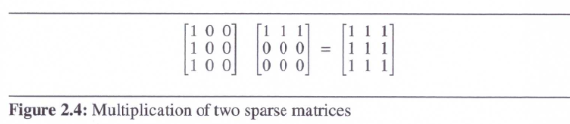

result _{ij} = 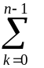a_{ik} b_{kj}

multiply two sparse matrices A and B represented as ordered lists

pick a row of A and find all elements in column j of B

have to scan all of B to find all the elements in column j

avoid this by first computing the transpose of B

put all column elements in consecutive order

do a merge operation

-> 실습: transpose한 후에 merge하는 coding

-> 곱셈은 복잡

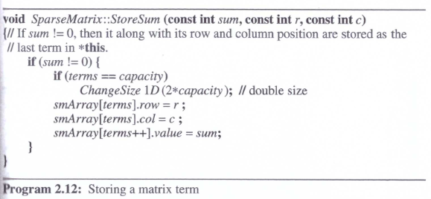
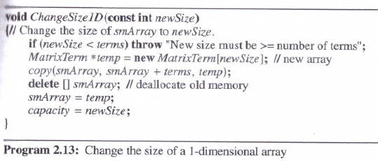

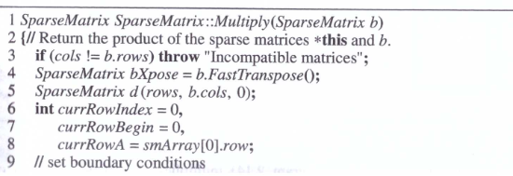

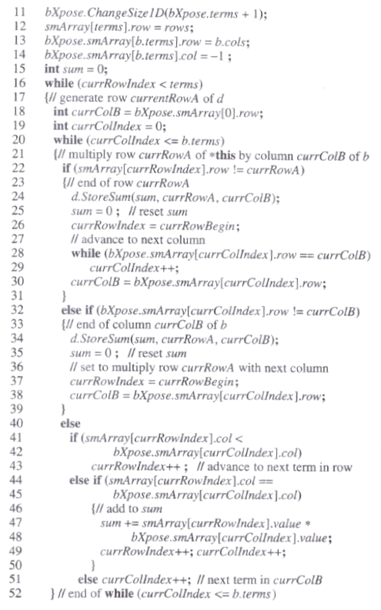

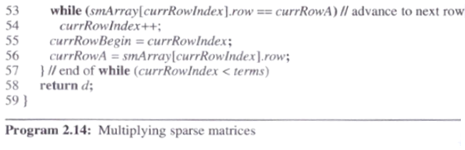

currRowA : the row of A that is currently being multiplied with the columns of B

currRowBegin: the position in a of the first element of row currRowA

currColB : the column of B that is currently being multiplied with the row currRowA of A

currRowIndex, currColIndex: successive elements of row currRowA and column currColB
-> examples에 대하여 변수 변화를 보여주는 시험 문제

Analysis of Multiply

lines 3 to 15: require only O(B.Cols + B.Terms)

lines 16 to 57: executed at most A.rows

lines 20 to 52: executed at most B.Terms

tr : # of terms in row r of A

the value of currRowIndex can increase at most tr times before currRowIndex moves to the next row of A

reset currRowIndex to currRowBegin in line 260

resetting can occur at most B.cols times

the total maximum increment in currRowIndex : B.cols * tr

the maximum number of iterations of lines 20-52: B.cols + B.Terms + B.cols * tr

the iteration with row currRowA of A : O(B.cols * tr + B.Terms)

the overall time : O(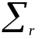(B.cols * tr + B.Terms)) = O(B.Cols* A.Terms + A.Rows*B.Terms)

the classical multiplication algorithm

for (int i=0; i<A.Rows; i++)

for (int j=0; j<B.cols; j++)

{

sum = 0;

for (int k =0; k<A.cols; k++)

sum += a[i][k] * b[k][j];

c[i][j] = sum;

}

O(A.Rows * A.Cols * B.Cols)

in the worst case, A.Terms = A.Rows * A.Cols or B.Terms = A.Cols * B.Rows

Multiply becomes slower by a constant factor

2.5 Representation of Arrays

Develop a representation in which mapping A[i][j]..[l] onto a position in a one-dimensional C++ array

Can retrieve multidimensional arrays efficiently

row major ordering or column major ordering

A[4..5][2..4][1..2][3..4]

using row major order

A[4,2,1,3], A[4,2,1,4], A[4,2,2,3], ..

lexicographic order

A[4,2,1,3] is stored at position 0

A[4,2,1,4] is stored at position 1

C++ 언어가 row major order를 지원, 알고리즘은 column major order가 필요할 경우, 계산식 필요

sequential representation of A[u1]

A[0] = A1, A[i] = A1 + i
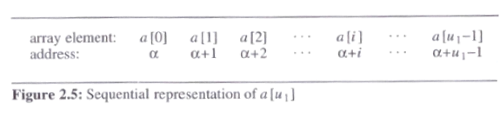

sequential representation of A[u1][u2]

A[0][0] = A1, A[i][0] = A1 + i * u2, A[i][j] = A1 + i*u2 + j

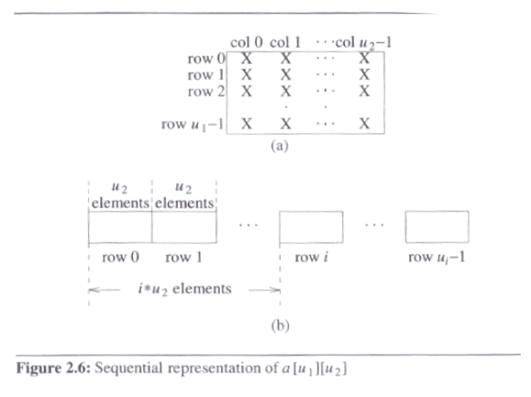

sequential representation of A[u1][u2][u3]

A[0][0][0] = A1, A[i][0][0] = A1 + i*u2*u3, A[i][j][0] = A1 + i*u2*u3 + j*u3

A[i][j][k] = A1 + i*u2*u3 + j*u3 + k

Template<class T>

class Matrix {

//3차원 matrix을 입력, display, 대각선 항의 합 구하기 등

public:

Matrix(int r=0, int c=0, int z = 0);

Matrix(const matrix<T>& m);

~Matrix() {delete [] element;}

. . .

private:

int rows, cols, zs;

T *element;
};

- 2.8 Additional Exercises
3. Fig 2.8 Lower and upper triangular matrics
5. Figure 2.9 Tridiagonal matrix
6. Fig 2.10 Square band matrix
